Fusion Annual Report April 2022- March 2023

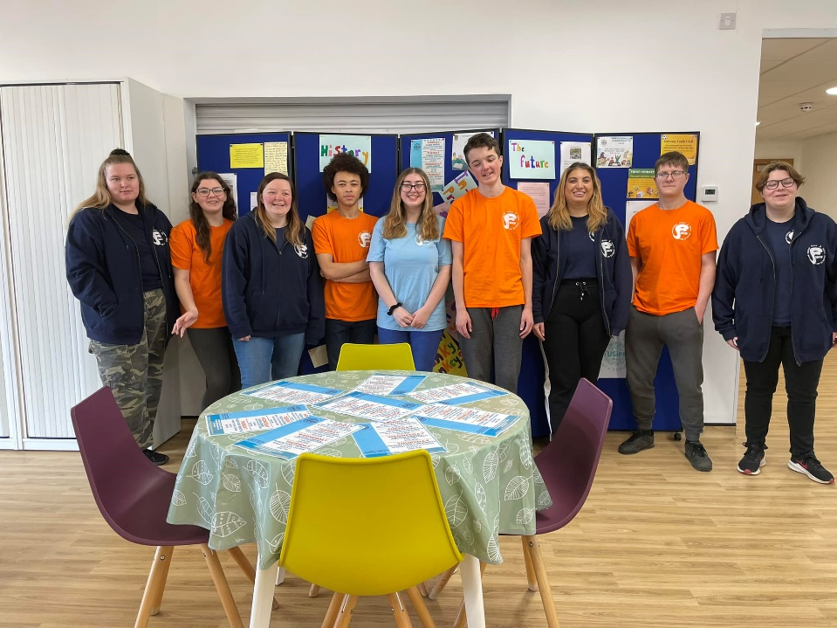

Number of young people worked with
In the last year we have been able to run all our clubs and projects and added some new ones. We have worked with approximately 174 different young people aged 8-25 as well as 35 parents with their 50 younger children.
Work we have delivered.
Fusion Seniors Orange t-shirt Project (14–17-year-olds) - Fusion seniors is a weekly youth club for our volunteers and young people wanting to volunteer in our clubs and local community. The group is mainly social, but we do have some training sessions, mental wellbeing subject discussions and sit as a group to eat and share our weekly news.
The Orange t-shirt volunteers residential.
12 Orange t-shirt volunteers went on a 2-day training residential to Grafham Water. They completed their Leadership training and worked hard to plan an engagement event to promote Fusion and discuss the possible building project. This weekend was supported by Stephanie Webb, Youth and Community Coordinator (Huntingdonshire) Cambridgeshire County Council, who delivered the training. Sarah Jane Gaul, Communications Officer Huntingdon Town Council, helped the young people with the engagement event, training them on answering difficult questions.

Fusion Gateway (young people with additional needs ages 12-25) - Fusion Gateway is for young people with additional needs. It is a club for the young people to make friends, play games, do sports, arts, and cooking. As some of the young people are older, we do sessions about independent living including cooking simple foods like pasta.
Fusion Juniors (school years 7-9) - Fusion Juniors is a weekly youth club for young people to take part in arts and sports activities. We often have a weekly theme based on issues that affect our young people like bullying, peer pressure and healthy relationships.
Fusion Funky Monkeys (ages 8-11) - Funky Monkeys is a weekly club for our young people to come to make friends and have fun. We do sports, games arts and crafts, transitional work for the year 6 's and healthy food cooking. This group is our busiest and regularly has 40+ in attendance each week.

Home Work Club (ages 8-14) - Working in conjunction with Huntingdon Communities Officer Charlotte Mann, this is an accessible, free provision to enable young people aged 8 - 14 to: study, complete homework, undertake revision and learning tasks and access the internet and library in a friendly, safe and secure environment.

In- School Projects - We are delivering weekly groups in both St Peters and Hinchingbrooke school working with referred groups of up to 10 young people. We deliver bespoke packages which can support mental wellbeing with sessions around, feelings, safer relationships, county lines, self-harm, internet safety etc.

Fusion Family trip - This year we had 2 trips in partnership with HCAP (Huntingdon Community Action Projects). In October half term we took 18 adults and 28 of their children to Shepreth Wildlife Park and in February we took 17 adults and 22 of their children to Sacrewell Farm. We were able to pay for their tickets, coach and make a packed lunch up for all the families. The families all attend a group which allows them to meet each week for a hot meal and the children can do a craft each week. Most of these families do not have transport or spare money to allow them to go on day trips as a family.
Quotes
“So nice to have something different to do, we couldn’t have afforded this ourselves or have the transport to get there”.
“It was good getting out of the house to do something so different, the children have loved the animals and their first time on a coach and they loved it.”

Easter Fusion 1 week provision – We provided 1 week of school holidays provision. This was funded by the HAF (Holiday Activities and Food) project but as we had other funding, we were able to provide spaces for more children to attend that were not on free school meals but still with many issues.
Summer Fusion 4 weeks provision - We provided 4 weeks of school holidays provision. This was funded by the HAF project but as we had additional funding, we were able to provide spaces for 20 more children to attend that were not on free school meals but still with many issues.

The Future
As we can no longer use Huntingdon Youth Child and Family Centre during the day or school holidays, it has meant our holiday clubs have had to be held outside so are very dependent on the daily weather – thankfully this summer this was not an issue as we only had 1 rainy day out of the 25-day scheme. This has also meant that we could not run the February and October holiday schemes, so we have used this time to take local families out on day trips, supporting this work broadens the scope of work Fusion delivers and starts helping us to forge early relationships with children and their families.
The manager, who is now full time, can no longer use the HYCFC base as an office, so they have moved to the Coneygear Centre, and we have had to hire this office space.
We have had support from Stephanie Webb, Youth and Community Coordinator (Huntingdonshire) Cambridgeshire County Council, to complete an application to the Youth Investment Fund (YIF) for £1.5 million for a purpose-built Youth Centre to house Fusion. Huntingdon Town Council have been very supportive and have offered us a lease on land on Coneygear Park. This is a very exciting proposition, and we will be looking closely at the pilot project in Wisbech to aid us in our application and future decisions.
It has been a great year and it is nice to be getting back to some normality after all the changes and challenges that Covid posed in the previous year. We would like to give a huge thanks to all the funders that have supported us this year so we can continue to support the young people and families in our community.

